Motor Vehicle & Trailer Excise Tax

Overview
Massachusetts residents must pay an annual motor vehicle excise tax for vehicles they own and register. The tax is collected by the city or town where the vehicle is garaged. Bills prepared using RMV registration info and sent to local assessors.
Reference:
M.G.L. Chapter 60 A (https://malegislature.gov/Laws/GeneralLaws/PartI/TitleIX/Chapter60A)

Excise Calculation / Valuation
Excise is levied at $25 per $1,000 of valuation. Valuation is based on the manufacturer's list price and vehicle age:
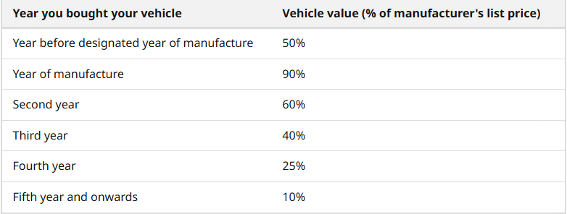

Collection & Payment
Payment is due 30 days from mailing. Failure to receive notice does not affect validity.
Taxes and adjustments are prorated by month. Even if registered for one day, tax is due for the full month.
For any payment-related questions, please contact the Tax Collector’s Office directly at (781) 631-1033 or via email at revenue2@marbleheadma.gov
Reference:
M.G.L. Ch. 60A 00§2 https://malegislature.gov/Laws/GeneralLaws/PartI/TitleIX/Chapter60a/Section2

Abatements

If a vehicle owner believes they are eligible for an excise adjustment, they should pay the bill in full to avoid late fees and interest. If an abatement is later approved, a refund will be issued. Submitting an abatement application does not stop the collection of taxes. Applications must be filed with the Board of Assessors within three years after the excise was due, or within one year after payment, whichever is later (MGL Ch. 60A §2). Timely filing is required to preserve the right to an abatement. Approved abatements are prorated by month. To proceed with any abatement request, you must provide documentation showing what happened to the plate and what happened to the vehicle. Scenarios include:
- Vehicle sold or traded
- Registration cancelled or transferred
- Vehicle registered in another state
- Vehicle totaled or stolen
- Death of registered owner
Please note: For leased vehicles, the leasing company is the legal owner and is responsible for applying for abatements.
Reference:
M.G.L. Ch. 60A Sections 1-7 https://malegislature.gov/Laws/GeneralLaws/PartI/TitleIX/Chapter60A

Before Applying for an Abatement:
Please refer to the handout for instructions and required documentation before submitting an abatement application.
Motor Vehicle Excise handout:
chrome-extension://efaidnbmnnnibpcajpcglclefindmkaj/https://marbleheadma.gov/wp-content/uploads/2025/03/aaaaa_draft_-_vehicle_excise_tax_abatement_handout.pdf
Abatement application (PDF): https://www.mass.gov/doc/boat-excise-abatement-application/download

Motor Vehicle Excise Tax Exemptions (MGL Ch. 60A §1)
Disabled Non-Veterans – Vehicles for personal use owned by individuals who:
  - Lost both legs or both arms, or
  - Have permanent loss of use of both legs or arms, or
  - Are legally blind in both eyes.
Disabled Veterans – Must provide VA-certified letter showing:
  - Loss of a foot or hand, or
  - Permanent vision impairment in one eye, or
  - 100% service-connected disability (HERO Act rules).
Prisoners of War & Surviving Spouses – One personal vehicle exempt if VA documents proof.
Massachusetts Military Personnel Vehicle exempt if on active duty outside MA for 180+ days (or wounded/killed in action).
Non-Massachusetts Military Personnel Vehicle exempt if stationed in MA under orders and domiciled in another state spouse’s vehicle may also qualify.
General Rules:
  - Only one vehicle per owner qualifies.
  - Must be for personal, non-business use.
Reference & Forms: [Mass.gov - Motor Vehicle Excise Exemptions] (https://www.mass.gov/info-details/motor-vehicle-excise-exemptions)
Hero Act:
To qualify for the motor vehicle excise tax exemption under the HERO Act, Massachusetts residents must present a letter from the U.S. Department of Veterans Affairs (VA) confirming they have a 100% service-connected disability rating or are deemed unemployable due to their service-connected disability. This documentation must be submitted to the city or town where the vehicle is principally garaged. The exemption applies to one vehicle per year, and the vehicle must be registered in the veteran's name.
https://www.mass.gov/info-details/hero-act

Jurisdiction & Garaging
The municipality that can assess the excise is determined by the place of garaging in RMV records as of January 1st.

Minimum Bill
Minimum bill: $5, minimum abatement: $5.

Overvaluation

If you believe your motor vehicle excise tax assessment is incorrect, you can contact the Massachusetts Registry of Motor Vehicles (RMV) to inquire about the valuation. The RMV can provide information regarding the manufacturer's suggested retail price (MSRP) used in the assessment.
Contact Information:
Phone: (857) 368-8000

