
DIRECTOR
KIMBERLY A. GRAD

TRUSTEES
GARY J. AMBERIK, CHAIR
JOHN WILLIAMS, VICE CHAIR
KATHY BARKER, SECRETARY
MARJORIE NORMAN
DAVID ROSS
KATHLEEN WASLOV

Abbot Public Library Board of Trustees
Meeting Minutes – April 6, 2026
Attendees:
Trustees: Gary Amberik, Kathy Barker, Marjorie Norman, David Ross, Kathleen Waslov, John Williams
Director: Kimberly Grad
Attending by Zoom:
Absent: None
Meeting was available via zoom

Published agenda:
L. Approval of March 2, 2025 Minutes/VOTE
II. Director’s report – Staff updates / Project Update / Invoice Approval
III. Report from the Chair
IV. FRIENDS UPDATE

Next Board Meeting May 11, 2025. Town meeting is Monday, May 4th and Town election is Tuesday, June 9, 2026.

CALL TO ORDER

The meeting location at the Library and held by zoom was called to order at 6:08 pm. Motion to approve the Minutes for the meeting on 3/2/2026. The Motion was seconded and approved.

ROLL CALL VOTE
Gary Amberik Yes
Kathy Barker Yes
Marjorie Norman Yes
Kathleen Waslov Yes
John Williams Yes

DIRECTOR’S REPORT

Service Hours
Closed on Monday, April 20, 2026 for Patriot’s Day.

Important Dates
Thursday, April 9 - 10 am Council on Aging - Outreach
Thursday, April 16 - 10 am Guest Speaker Ashley Stewart from Every Library who will offer advice about Board & Staff Do’s & Don’ts for Library Information-Only Campaigns
Fridays, May 1, 8, 15, 22, 29 Coffee with Board Members
June 5 - 9:30-10:30 am
April 21-25, 2026 National Library Week
Tuesday, April 21: National Library Workers Day, a day for library staff, users,
administrators, and Friends groups to recognize the valuable contributions made by all
library workers.
Wednesday, April 22: National Library Outreach Day, a day to celebrate library outreach
and the dedicated library professionals who are meeting their patrons where they are.
(Welcome Baby kits for Marblehead Pediatrics).
Thursday, April 23: Take Action for Libraries Day, a day to rally advocates to support libraries. (We will take note of this for our positive social media messages).

Staff Updates
Children’s Librarian Marcia Cannon will retire on May 2, 2026.

March Statistics in Brief:
● Door counts surged to 8,074, an increase of 2,915 over February.
● 400 people visited the library on Saturday, March 7 to attend WinterFest, meetings and other programs.
● 18,846 items were checked out (11,864 print and 7,162 digital).
● 9,311 patrons (holding steady for the past 6 months).
● 34 children, teens, adults participated in 6 Makerspace programs in March.

FY27 Budget
● The balanced budget staffing plan has been shared with staff.
● Override scenarios have been submitted to the Town Finance Director and Town Administrator for consideration.
● The APLF is working on a survey to send to all Abbot Public Library and APLF contacts (Constant Contact, etc.)
● The APLF is sponsoring a Library community awareness/ positive messaging campaign with Hyphenate, the company that created and maintains the Abbot Public Library website.

Building Updates
● The Town has provided contract and contact information for a plumber and an electrician.
● Sprinkler repair - Rustic Fire Prevention - completed March 9 - additional request
● Driftwood Garden proposal for Max’s Garden - on hold until further notice.

Misc
● Strategic Planning has been postponed, but the APLF survey questions will serve as our questionnaire.
● $250 membership fee is due to maintain Rotary Club membership.

Requesting the following motions for approval
1. Carten Gallery Fund: $75 For the Marblehead Festival of Arts toward the purchase of prizes for winners of the youth writing contest.
2. $2,795.82 for Rustic Fire Prevention to replace another corroded 4-inch OS&Y valve.

April 2026 Program Summary
Marblehead 250
In anticipation of the United States’ Semiquincentennial, we have launched the Marblehead 250 series: ten illustrated talks exploring our town’s critical role in the American Revolution. April’s highlights include:
● Revolutionary Near Miss: An exploration of how the first shots almost occurred in Marblehead in February 1775.
● The Pitt Packet Incident: A look at early maritime resistance and the rise of John Adams.
● Burial Court Heroes: A specialized session on the local patriots interred in Marblehead’s historic graveyards.

Adult Learning & Wellness
Our commitment to lifelong learning is reflected in a diverse array of adult programming. We continue our partnership with the Massachusetts Center for the Book for the 2026 Reading Challenge and offer weekly Coffee at the Library sessions to foster social cohesion. The library continues to serve as a vital safety net for the community, evidenced by our ongoing Open Hours with Counselor Gina Rabbitt, providing residents with direct access to mental health resources and referrals.

Technology & Innovation
Weekly drop-in tech help and a beginner’s 3D Printing workshop in the Thompson Makerspace.

Virtual Lectures
Through our partnership with Road Scholar, we are hosting high-profile virtual sessions featuring Emmy-winner Jane Pauley, as well as lectures on Antarctic exploration, the neuroscience of aging, and the secrets of King Tut.

Environmental & Scientific Awareness
To coincide with Earth Day, we are hosting lectures on Salem Harbor water quality and the “Secret Lives of Native Bees” in collaboration with the Marblehead Conservancy.

Youth & Family Services
April programming for younger patrons emphasizes STEAM (Science, Technology, Engineering, Arts, and Math) and literacy. Key initiatives include:
● Makerspace Activities: Powering Flight circuit-building workshops for children and Cardboard Upcycling for teens to celebrate Earth Day.
● Recurring Literacy: Weekly Story Time A-Go-Go and Music and Movement sessions continue to support early childhood development, while the Afterschool Chess Club provides a disciplined environment for cognitive growth.

STATISTICS
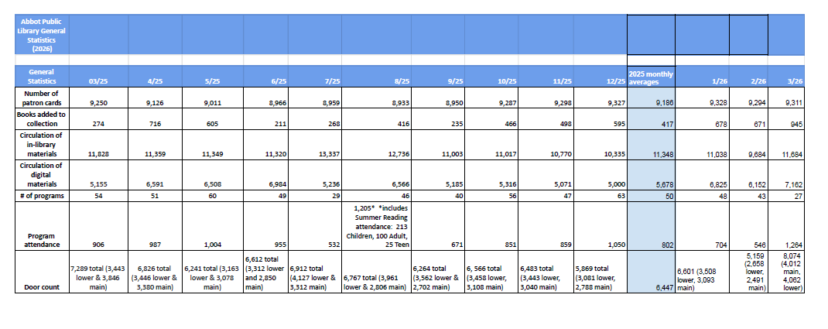

Discussion of Director’s Report

The statistics were reviewed and clarified as Patrons are card holders and future reporting will describe digital vs print circulations.

There was a review of the budget and staffing levels planned for the ‘Balanced budget’ as recently approved by FIN Com and Select board. There was also a review of plans for the ‘Tier 1-3’ proposed override budgets of partial restoration (1), return to level funded (2) and growth budge (3). In each scenario there is an increase in service hours (25-45-52), staffing (loss of 8 positions to return to 24 positions), and return to a materials purchases. Certification waivers with the state will be attempted under the scenarios ‘balanced and Tier 1’. The details were considered draft until meetings are held with Town Manager and Administrator for approvals.

The APLF funded survey will capture community awareness and interest. It is anticipated that the Library and Board will be providing further information to the public over the next month as the override proposals are finalized. Due to the anticipated communication needs as the town budget evolves, additional board meetings will be scheduled. We will work on preparation for the Town Meeting. We will hold on the decision of joining the rotary club. A draft proposal will be circulated for Shattuck Fund for various. The Director will be attending the Town Warrants meeting and Select Board meetings.

There was a Motion for approval of the following items for payment:
1. Carten Gallery Fund: $75 For the Marblehead Festival of Arts toward the purchase of prizes for winners of the youth writing contest and
2. $2,795.82 for Rustic Fire Prevention to replace another corroded 4-inch OS&Y valve from the override account.

The Motions was seconded and voted as approved.

ROLL CALL VOTE
Gary Amberik Yes
Kathy Barker Yes
Marjorie Norman Yes
David Ross Yes
Kathleen Waslov Yes
John Williams Yes

CHAIRMAN’S REPORT
See points above on Town meetings and building repairs. The Fire prevention repairs were reviewed and considered reasonable due to cost of valve and time to install.

FRIENDS REPORT
-March 21 Book Sale was the most successful one to date in funds and attendance.
-Pam Peterson’s Marblehead in 1776 presentation is on April 11 in coordination with the LWV.
-A Pop-Up Book Sale at the COA is scheduled on Tuesday, April 28, 2026, from 9:00 a.m.- 1:00 p.m. the day of the Kentucky Derby luncheon.

APLF
Meetings took place with work on the survey and overall support of the library during the upcoming budget, town meeting and elections.

There was a Motion to adjourn. Motion seconded. All approved.

ROLL CALL VOTE
Gary Amberik Yes
Kathy Barker Yes
Marjorie Norman Yes
David Ross Yes
Kathleen Waslov Yes
John Williams Yes

The meeting was adjourned at 6:50 PM.
The board then went into an executive session.

End of Meeting Minutes

